PHASE 5 – Creating a New Service Portal
Create a dedicated Service Portal where employees can access the Raise Employee Issue Record Producer through a clean and user-friendly interface.

Creating the Portal
1. Navigate to Service Portal → Service Portal Configuration.
2. Click New.
3. Title: Requesting portal.
4. URL suffix: employee_request.
5. Homepage: ec_standard_home.
6. KB home page: esc_knowledge_home.
7. Login page: login.
8. Upload the required logo.
9. Main menu: Employee Center Menu.
10. 404 Page: 404.
11. Theme: Employee Center Coral Theme.
12. Save the portal.

Creating a Portal Page
1. Navigate to Service Portal → Pages.
2. Click New.
3. Title: Employee Center Portal Page.
4. ID: employee_center_portal_page.
5. Save the page.
New Service Portal form
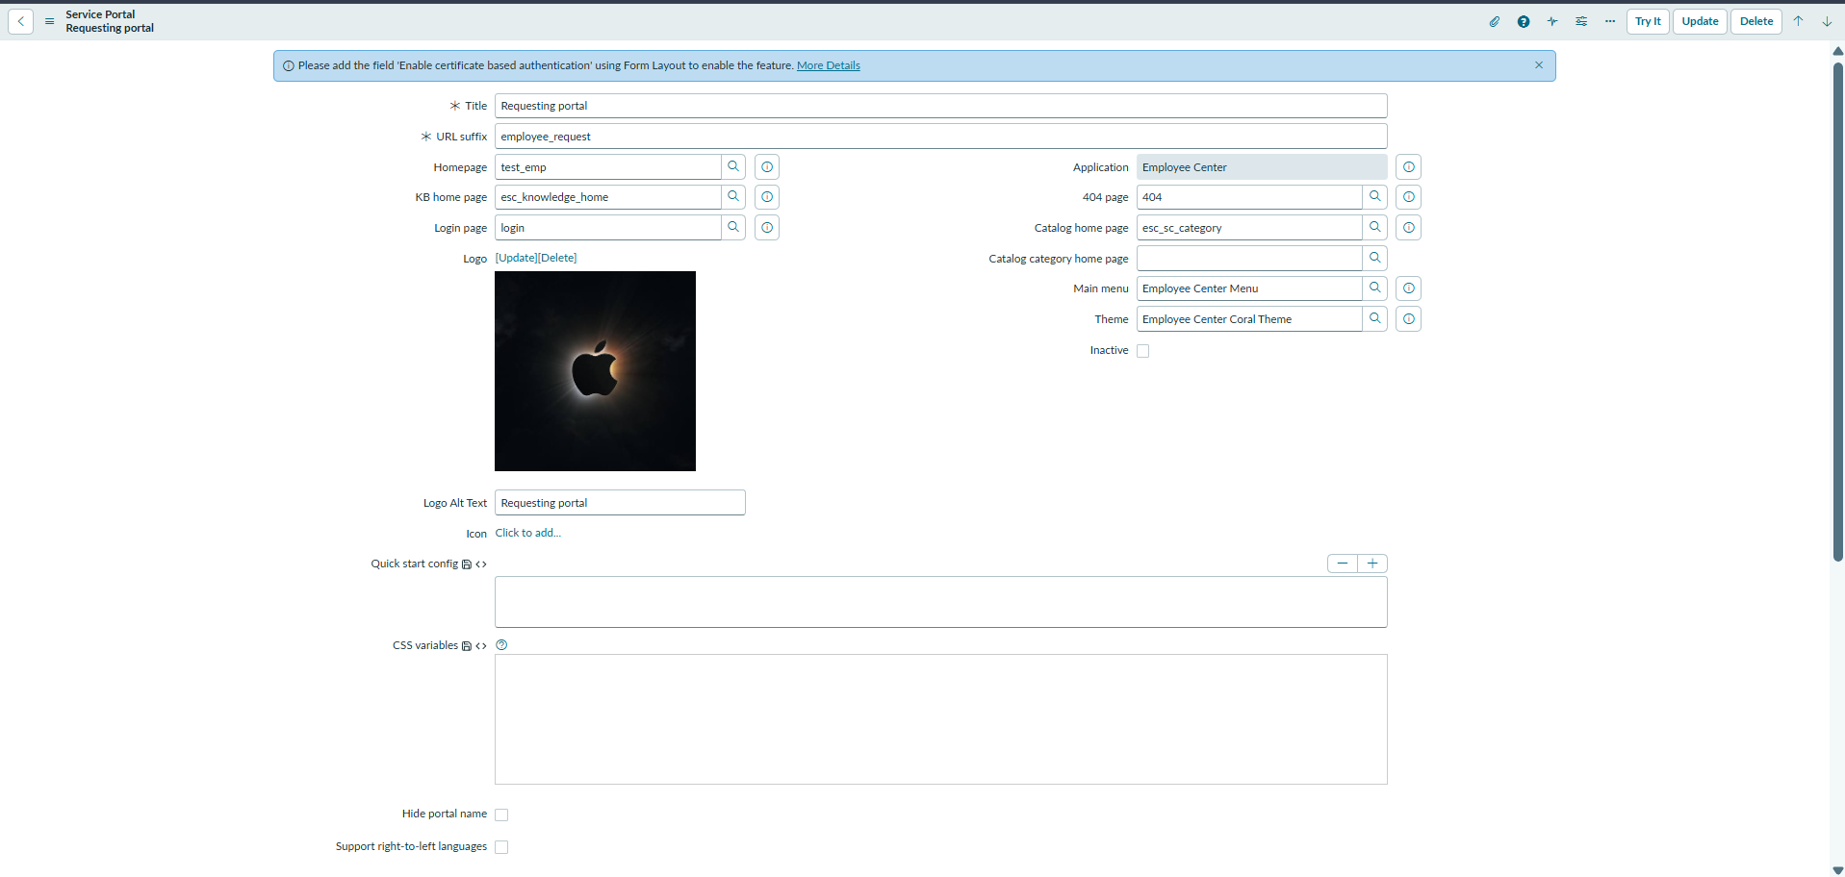
Employee Center Portal Page
